List of interviewers surveying households in Shymkent in 2025.

- List of interviewers The level of public confidence in law enforcement agencies and the judicial system
№ | City, region | Ful name | Photo
1 | Shymkent | Berkimbaeva Bakhyt Tasbolatovna | 
2 | Shymkent | Aldiyarkyzy Azhar | 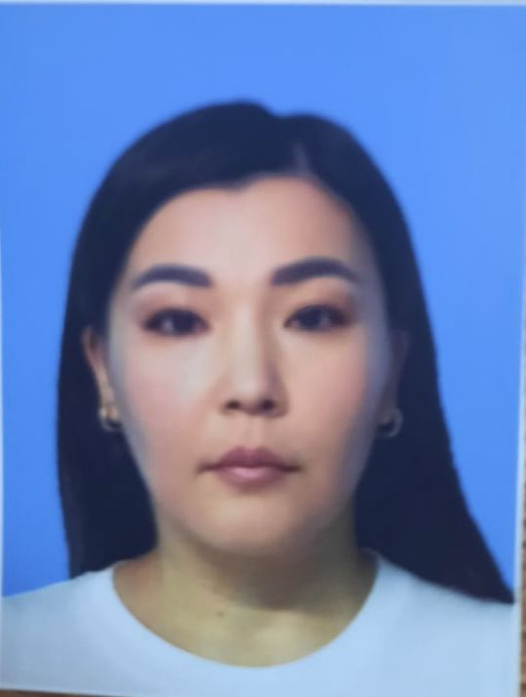
3 | Shymkent | Nurbek Sholpan Myrzadauletkyzy | 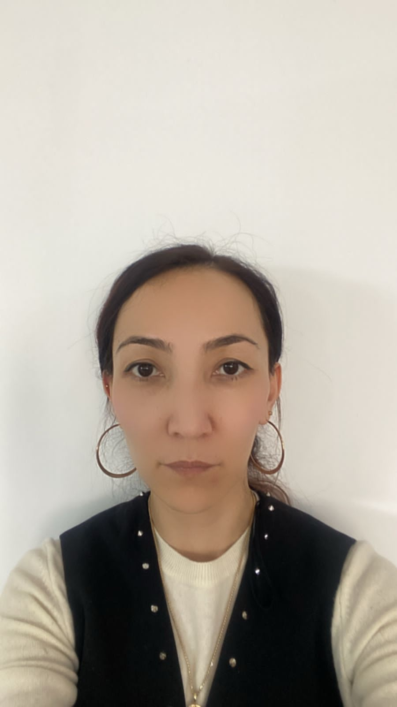
4 | Shymkent | Aldabergenova Arailym Azimkhanovna | 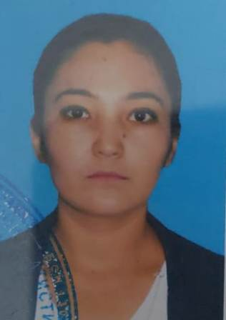
5 | Shymkent | Tasbolatova Regina Kairatovna | 